**TRF Level 2 2022 Task Report**

Task No.:

Title: Voltage regulator

Name: Vaishnavi Ramchandra davari

GR No.: 12110729

E-mail ID: Vaishnavi.davari21@vit.edu

**INDEX**

|  |  |
| --- | --- |
| 1. | Introduction |
| 2. | Working methodology |
| 3. | Insights |
| 4. | Circuit Diagram (if any) |
| 5. | Result |
| 6. | References |

1. INTRODUCTION

This is template of task report. In this, describe your task.

Hardware:

(Components in the circuit)

Software:Proteus,eagle

(Software used)

2. WORKING METHODOLOGY

(Mention steps taken to complete the task)

**Working of the circuit/ Algorithm/ Flowchart/ Equation:**

(Explain the working of the circuit, algorithm, equations, calculations, simplication, etc)

3. INSIGHTS

(Problems (errors) faced while completing the task)

4. CIRCUIT DIAGRAM (if any)

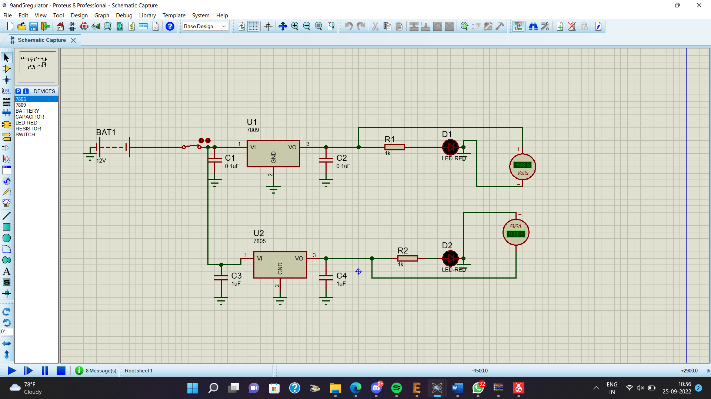

5. RESULT

(Attach Screenshot of Simulations, Output, Design, etc)

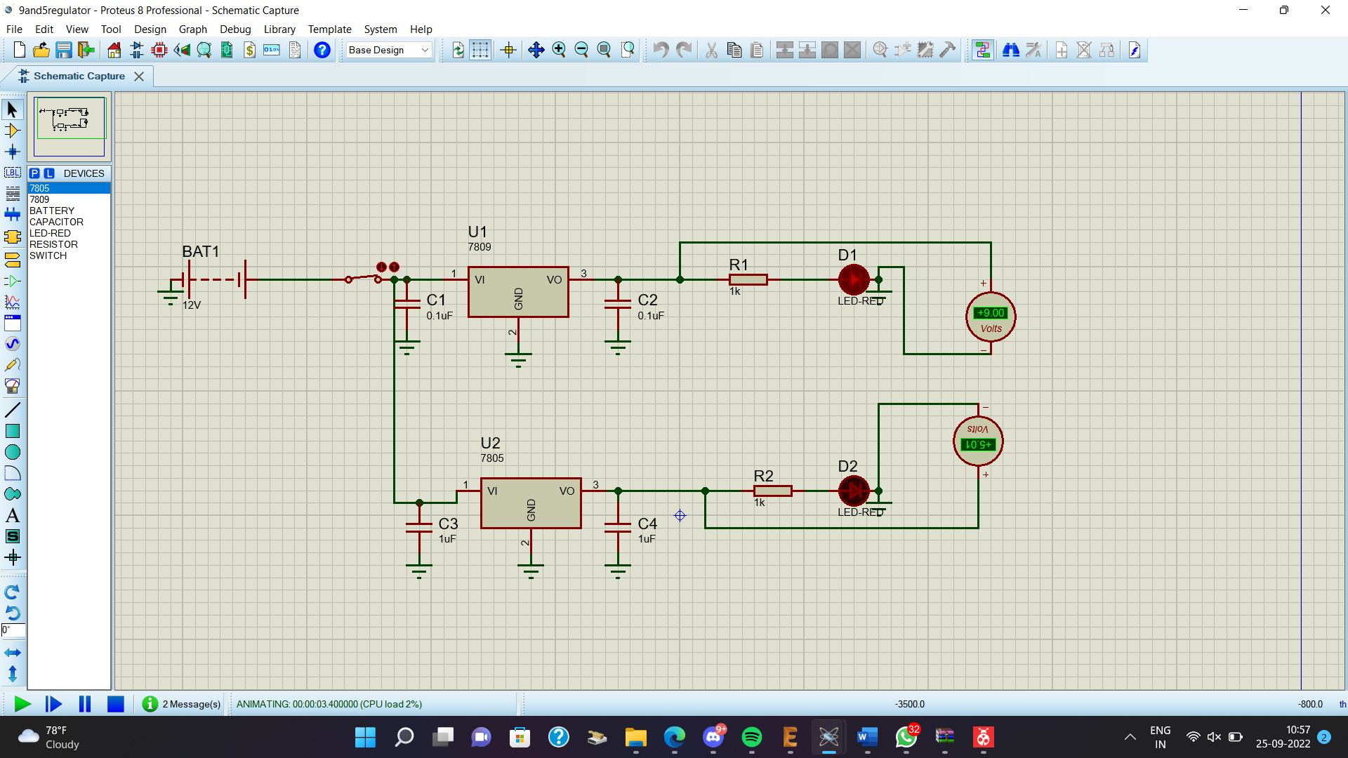

6. REFERENCES

(datasheets, sites that you used to complete the task)